EXPERIMENT 10

10.1.1// Remove Punctuations from a String
ALGORITHM:
STEP 1: Start
STEP 2: Take input string → st
STEP 3: Initialize an empty string → s = ""
STEP 4: For each character i in st:
  - If i is alphanumeric (i.isalnum())
OR
  - If i is a space (i.isspace())
    - Then append i to s
STEP 5: After the loop ends, print s
STEP 6: End

FLOWCHART:
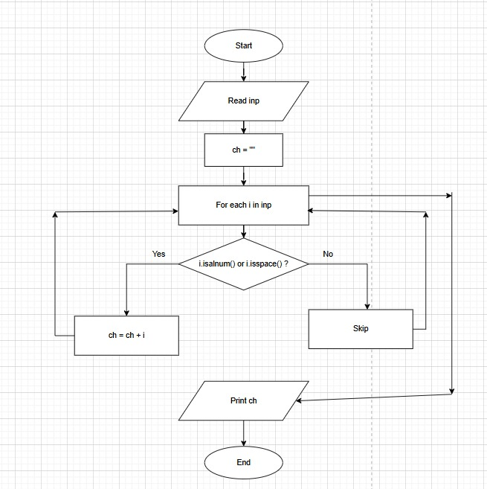
CODETANTRA:

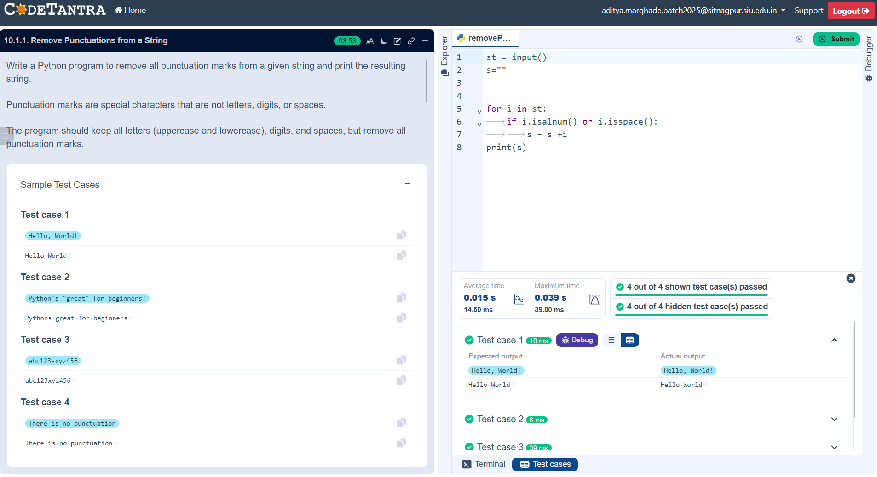

10.1.2// Reverse a String
ALGORITHM:
STEP 1: Start
STEP 2: Define a function reverse_string(str1)
STEP 3: Initialize an empty string res = ""
STEP 4: Find the length of the string → ln = len(str1)
STEP 5: Loop from index ln - 1 down to 0:
- Append each character str1[i] to res
STEP 6: Return res
STEP 7: Take input from user → user_input
STEP 8: Call the function → result = reverse_string(user_input)
STEP 9: Print the original string
STEP 10: Print the reversed string
STEP 11: End
FLOWCHART:
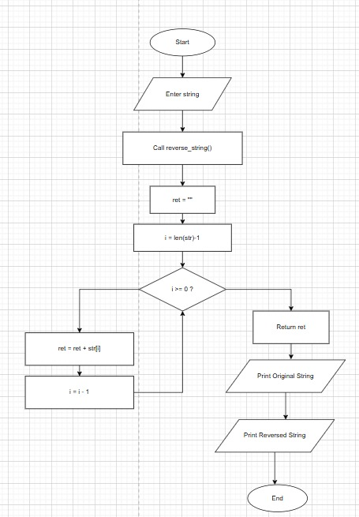
CODETANTRA:
